**SNOWFLAKE**

***Architecture***

1. Snowflake enables data storage, processing, and analytic solutions that are faster, easier to use, and far more flexible than traditional offerings.
2. Snowflake provides all of the functionality of an enterprise analytic database, along with many additional special features and unique capabilities.
3. There is no hardware (virtual or physical) to select, install, configure, or manage.There is virtually no software to install, configure, or manage.Ongoing maintenance, management, upgrades, and tuning are handled by Snowflake.
4. Snowflake runs completely on cloud infrastructure. All components of Snowflake’s service (other than optional command line clients, drivers, and connectors), run in public cloud infrastructures.
5. Snowflake’s architecture is a hybrid of traditional shared-disk and shared-nothing database architectures. Similar to shared-disk architectures, Snowflake uses a central data repository for persisted data that is accessible from all compute nodes in the platform. But similar to shared-nothing architectures, Snowflake processes queries using MPP (massively parallel processing) compute clusters where each node in the cluster stores a portion of the entire data set locally. This approach offers the data management simplicity of a shared-disk architecture, but with the performance and scale-out benefits of a shared-nothing architecture.
6. 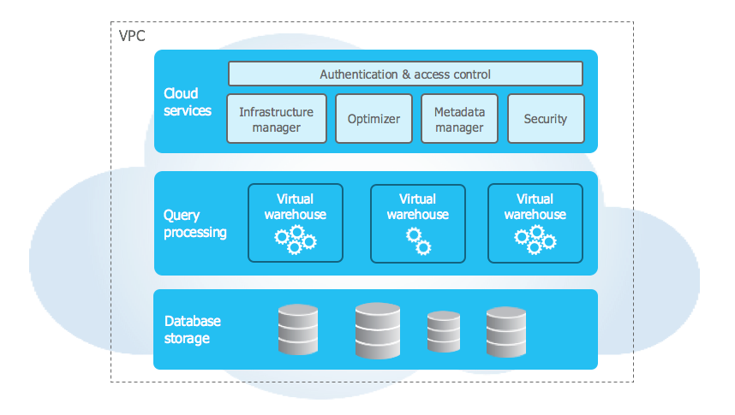

**Database Storage**

* Snowflake manages all aspects of how this data is stored — the organization, file size, structure, compression, metadata, statistics, and other aspects of data storage are handled by Snowflake. The data objects stored by Snowflake are not directly visible nor accessible by customers; they are only accessible through SQL query operations run using Snowflake.

**Query Processing**

• Query execution is performed in the processing layer. Snowflake processes queries using “virtual warehouses”. Each virtual warehouse is an MPP compute cluster composed of multiple compute nodes allocated by Snowflake from a cloud provider.Each virtual warehouse is an independent compute cluster that does not share compute resources with other virtual warehouses. As a result, each virtual warehouse has no impact on the performance of other virtual warehouses.

**Cloud Services**

* The cloud services layer is a collection of services that coordinate activities across Snowflake. These services tie together all of the different components of Snowflake in order to process user requests, from login to query dispatch. The cloud services layer also runs on compute instances provisioned by Snowflake from the cloud provider.

Services managed in this layer include:

* Authentication
* Infrastructure management
* Metadata management
* Query parsing and optimization
* Access control

***Connecting to Snowflake***

* A web-based user interface from which all aspects of managing and using Snowflake can be accessed.
* Command line clients (e.g. SnowSQL) which can also access all aspects of managing and using Snowflake.
* ODBC and JDBC drivers that can be used by other applications (e.g. Tableau) to connect to Snowflake.
* Native connectors (e.g. Python, Spark) that can be used to develop applications for connecting to Snowflake.
* Third-party connectors that can be used to connect applications such as ETL tools (e.g. Informatica) and BI tools (e.g. ThoughtSpot) to Snowflake.

# ***Logging in to Snowflake***

1. In a supported web browser, navigate to [https://app.snowflake.com](https://app.snowflake.com/).
2. Provide your [account name](https://docs.snowflake.com/en/user-guide/admin-account-identifier.html#label-account-name) or account URL. If you’ve previously signed in to Snowsight, you might see an account name that you can select.
3. Sign in using your Snowflake account credentials.

***Snowflake Ecosystem***

Snowflake works with a wide array of industry-leading tools and technologies, enabling you to access Snowflake through an extensive network of connectors, drivers, programming languages, and utilities, including:

Certified partners who have developed cloud-based and on-premises solutions for connecting to Snowflake.

Other 3rd-party tools and technologies that are known to work with Snowflake.

Snowflake-provided clients, including SnowSQL (command line interface), connectors for Python and Spark, and drivers for Node.js, JDBC, ODBC, and more.

For more information pl follow the below link:

<https://docs.snowflake.com/en/user-guide/ecosystem-all>

# ***Virtual Warehouses***

A virtual warehouse, often referred to simply as a “warehouse”, is a cluster of compute resources in Snowflake. A virtual warehouse is available in two types:

* Standard
* Snowpark-optimized

A warehouse provides the required resources, such as CPU, memory, and temporary storage, to perform the following operations in a Snowflake session:

* Executing SQL SELECT statements that require compute resources (e.g. retrieving rows from tables and views).
* Performing DML operations, such as:

Updating rows in tables (DELETE , INSERT , UPDATE).

Loading data into tables (COPY INTO <table>).

Unloading data from tables (COPY INTO <location>).